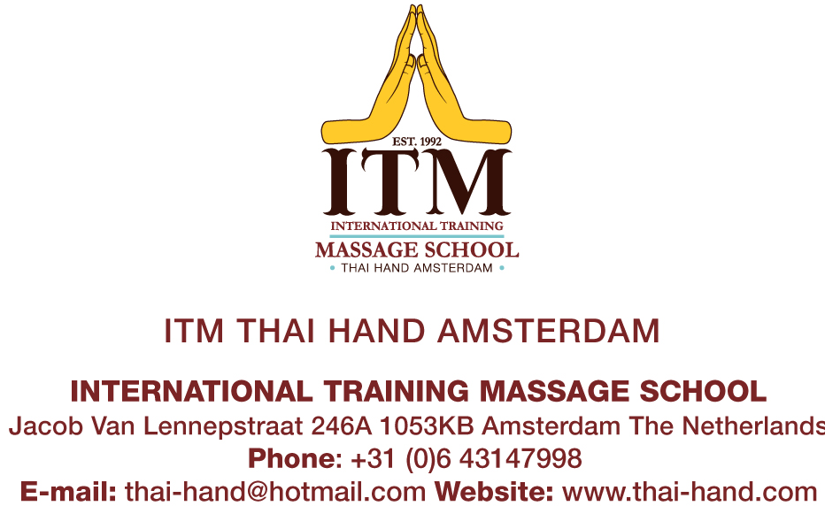

Professional Thai yoga massage courses now in Berlin

Like to learn professional traditional Thai yoga massage and receive an internationally recognized certificate? Join a Thai yoga massage course at ITM Thai Hand Berlin.
ITM Thai Hand Berlin is a franchise from ITM, (International Training Massage Chiang Mai) and ITM Thai Hand Amsterdam, registered at CRKBO (Central Register Short Professional Education )
All teachers are qualified, certified and recognized by ITM (International Training Massage School of Chiang Mai, northern Thailand). Students who follow ITM Thai Hand’s courses will receive certificates, acknowledged by the Thai government, Department of Health and Education in Thailand.

ITM is accredited by Thailand Ministry of Education, approved by Ministry of Public Health and recognized and approved internationally by many professional colleges and associations for continuing education in the regulated healthcare field.
ITM Method of Teaching
ITM uses the universal VAK (visual, auditory, kinesthetic) method of teaching. Our students learn through emulation of their teachers’ demonstrations to perform hands-on practice, following their teachers’ movements to ensure correct technique.

ITM Thai Hand Berlin offers the following Professional Courses:

Level I: Foundation of Traditional Thai Yoga Massage (30 hours)
Prerequisite: None

- This course covers Front Position (feet to face)
- Introduces the concept of energy lines (SEN) and Yin/Yang
- Teaches stretches, acupressure points, and proper use of body weight using thumbs, palms, elbows, knees and feet
- Emphasizes deep-focused abdominal (Hara) work
- Upon completion students will be able to perform an effective 1 - 1 ½ hour Thai Massage

Level II:Intermediate Traditional Thai Yoga Massage (30 hours).
Prerequisite: ITM Level I
- Expands on the techniques learned in Level I to cover the Side, Back (Prone) and Sitting Positions
- Advanced yoga like stretching movements
- Upon completion students will have a substantial foundation of the major positions of Thai Massage and can expect to perform a comprehensive 1 ½ to 3 hour Thai Massage

Level III: Advanced Sen – Energy Lines (30 hours)
Prerequisite: ITM Level I and II
- In-depth knowledge of the 10 major energy lines (SEN) and their application combined with the movements learned in Level I and II
- Learn the Theory of SEN and compare them with the fourteen meridians (Chinese medicine), Nadi (Indian Yoga) and Reiki
- Additional advanced yoga like stretching positions to open and activate the SEN
- Advanced deep-focused abdominal (Hara) work

Level IV: Advanced Therapeutic Thai Massage (30 hours)
Prerequisite: ITM Level I and II
- This course examines the therapeutic aspects of Thai Massage
- Learn advanced techniques of applying pressure using thumbs, palms and fingers
- Study acupressure points to relieve ailments such as headache, back pain, knee pain, shoulder/neck pain caused by various conditions of physical and mental stress
- Learn how to work properly on the acupressure points and how to combine them in a Thai Massage for effective healing.

